**Aaditya Bachal**

**Project Title: User Response Prediction System using Machine Learning Techniques**

1. **Problem Statement**  
   The online advertising industry, valued in billions of dollars, relies heavily on understanding user behavior, particularly predicting whether users will engage with ads. Click-Through Rate (CTR) is a key metric used to gauge this interaction. Advertisers are interested in maximizing the CTR to ensure that their advertising spending is effective, while search engines and platforms like Google use these predictions to optimize which ads are displayed, aiming to increase revenue.

**Project Goal**: Develop a machine learning model to predict whether a user will click on an ad.

**Key Variables**:

* + Age
  + Daily time spent on the site
  + Internet usage
  + Income
  + Geographic location

**Objective**: Identify patterns in user behavior that influence ad engagement.

**Challenges**: Accurately predict click behavior, considering the diverse and complex nature of user data.

**Machine Learning Models Explored**:

* + Logistic Regression
  + Random Forest

1. • **Outcome**: Enhance ad targeting strategies by helping marketers focus on users more likely to engage with ads.**Abstract**  
   The User Response Prediction System focuses on forecasting ad clicks by analyzing user characteristics like age, daily internet usage, and geographic location. By building machine learning models such as logistic regression and random forest classifiers, the system aims to predict whether a user will click on an ad based on these factors. The dataset consists of features like time spent on a website, area income, and user demographics, with the key target variable being whether or not a user clicked on an ad.

The project's methodology includes thorough data preprocessing, feature extraction, and model evaluation using metrics like accuracy and AUC (Area Under the Curve). The logistic regression model offered interpretable insights into user behavior, while the random forest model achieved higher accuracy, reaching 96%. The conclusion highlights the effectiveness of targeting users with low internet usage for maximizing ad click potential, providing a valuable tool for marketers looking to optimize ad placements and increase engagement.

1. **Literature Survey**

3.1 **User Response Prediction and CTR**  
User response prediction, especially in the context of online advertising, has evolved over the years. Predicting CTR is an integral part of how search engines and advertisers optimize their revenue streams. Traditional models have used simple algorithms like logistic regression to predict user behavior. However, advancements in machine learning have introduced more complex methods, including decision trees, random forests, and deep learning models.

3.2 **Online Advertising Ecosystem**  
The rise of real-time bidding (RTB) systems in online advertising has made CTR prediction more crucial. In these systems, advertisers bid in real-time for ad space, and the platform must quickly predict which ads are likely to be clicked by the user. This bidding is influenced by factors like user demographics, behavior, and the content of the ads. Research shows that efficient CTR prediction not only improves ad targeting but also leads to better ad placement optimization, lowering costs for advertisers while increasing profits for search engines.

3.3 **Machine Learning in CTR Prediction**  
Machine learning models, particularly classification algorithms, are well-suited for CTR prediction tasks. Random forests, in particular, have been shown to handle the complex and high-dimensional nature of advertising data effectively. Studies also show that deep learning models, although more computationally intensive, can further improve prediction accuracy by capturing complex relationships in the data. However, simpler models like logistic regression remain popular for their interpretability, making them more applicable in scenarios where transparency is important.

1. **Methodology**

The project is structured into several key phases, each building upon the last to ensure an accurate and robust user response prediction model.

4.1 **Data Collection and Understanding**  
The dataset used for this project contains 10 variables related to user behavior and demographics, such as 'Daily Time Spent on Site', 'Age', 'Area Income', and the target variable 'Clicked on Ad'. These features are extracted from the online activity of users interacting with advertisements.

| **Feature** | **Description** |
| --- | --- |
| Daily Time Spent on Site | Time spent by the user on a website (in minutes) |
| Age | The user's age (in years) |
| Area Income | The average income in the user's geographic area |
| Daily Internet Usage | Average time a user spends on the internet daily (in minutes) |
| Ad Topic Line | The headline or topic of the advertisement |
| City | The city where the user resides |
| Male | Whether the user is male (1) or not (0) |
| Country | The country where the user is located |
| Timestamp | The exact time when the user interacted with the ad |
| Clicked on Ad | Whether the user clicked on the advertisement (1) or did not click (0) |

4.2 **Data Preprocessing**  
Preprocessing is one of the most critical steps in machine learning, ensuring that the data is clean, well-structured, and ready for analysis. This process included:

* Handling missing data: Rows with missing values were either filled with appropriate imputed values or removed entirely.
* Feature transformation: The 'Timestamp' feature was transformed into month, day of the week, and hour fields to enable better time-based analysis.
* 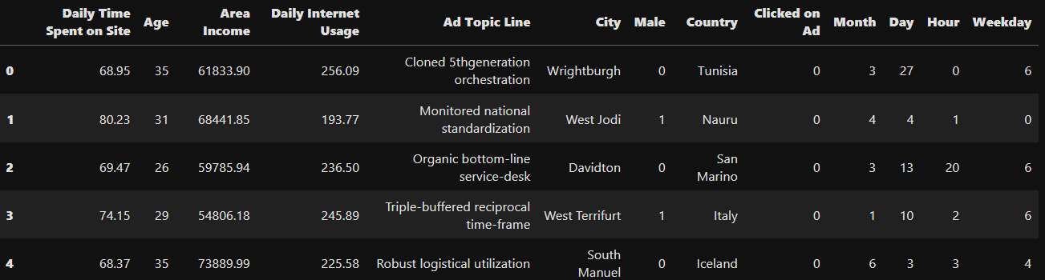
* Categorical variables: Variables such as 'Ad Topic Line' and 'City', which had a large number of unique values, were dropped due to their irrelevance in prediction.

The dataset was then split into training and testing sets, with 80% used for training the model and 20% for testing.

4.3 **Exploratory Data Analysis (EDA)**  
Exploratory data analysis helped uncover insights into how different features relate to the target variable ('Clicked on Ad'). Key visualizations included:

* Histograms and distributions: These showed how variables like 'Daily Time Spent on Site' and 'Age' are distributed among users who clicked on ads versus those who did not.
* 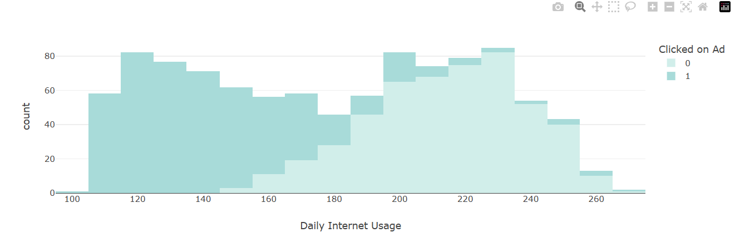
* Correlation heatmap: A heatmap was used to identify the relationships between features and the target variable. 'Daily Internet Usage' and 'Daily Time Spent on Site' were found to be strongly correlated with the likelihood of clicking on an ad.
* 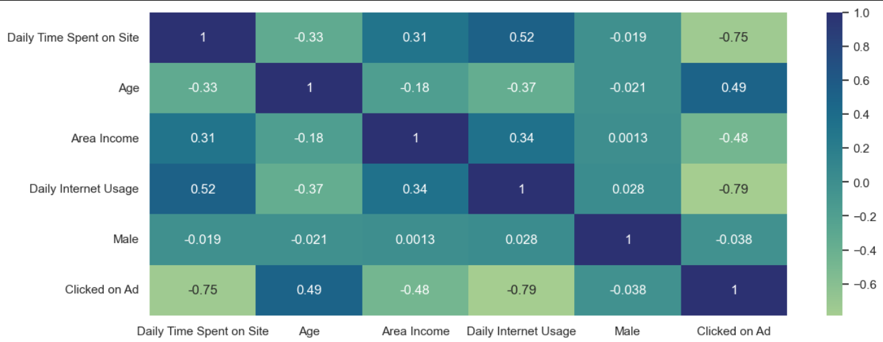
* **Comparison of users who have clicked on an ad or not in terms of age and weekday. People of higher age tend to click on an ad.**

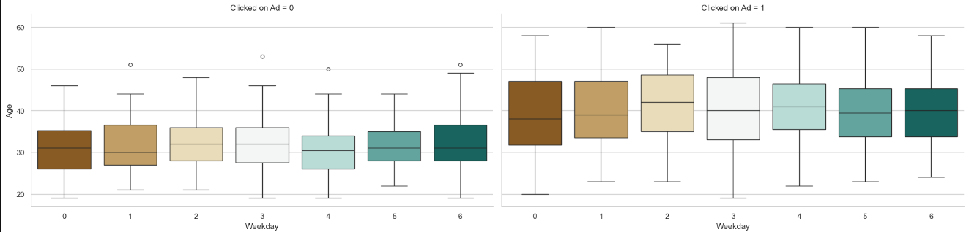

Once the dataset is processed, we need to divide it into two parts: training and test set. We will

import and use the train_test_split function for that. All variables except 'Clicked on Ad' will be

the input values X for the ML models. The variable 'Clicked on Ad' will be stored in y, and will

represent the prediction variable.

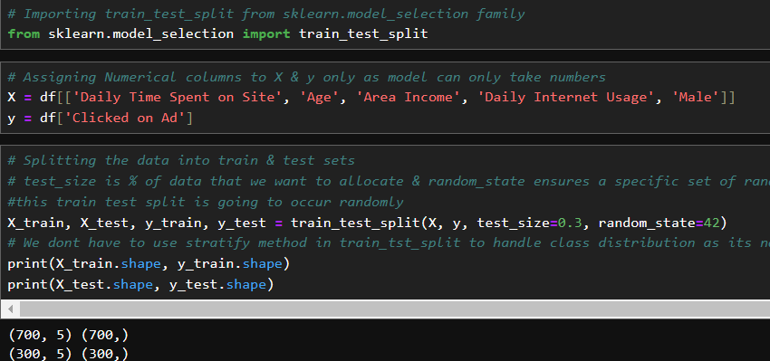

4.4 **Algorithm Implementation**  
The project experimented with multiple machine learning algorithms to predict user response:

1. Logistic Regression: A straightforward model useful for binary classification tasks like predicting whether a user will click on an ad.

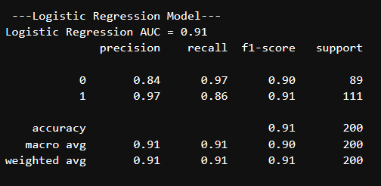

1. Random Forest Classifier: A more complex model that uses multiple decision trees to improve predictive accuracy. This model was particularly effective in handling the non-linear relationships between features and the target variable.

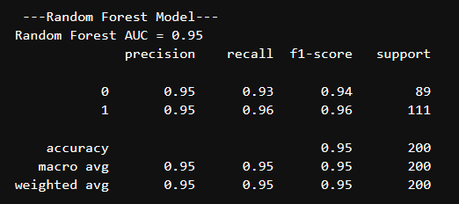

1. **Results**

5.1 **Model Evaluation**  
Each model's performance was evaluated using key metrics such as accuracy, precision, recall, and AUC:

1. Logistic Regression: Achieved reasonable accuracy and was the most interpretable model, allowing for clear insights into which features contributed to ad clicks.
2. Random Forest: Delivered the highest accuracy, reaching 96%. It was also robust in handling overfitting, making it a reliable choice for this classification task.

5.2 **Feature Importance**  
Random forest provided insights into the importance of each feature. The most predictive features were:

* Daily Internet Usage: Users with lower internet usage were more likely to click on ads.
* Daily Time Spent on Site: Similarly, users spending less time on websites were more inclined to engage with ads.

5.3 **Visualizations**  
Several key visualizations helped in interpreting the model results:

* ROC Curves: Plotted to compare the performance of different models.

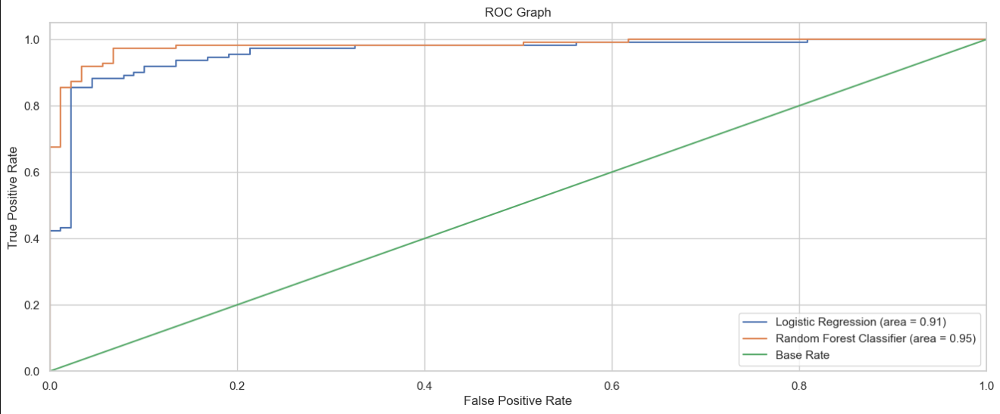

6.**Conclusion**

The User Response Prediction System successfully predicted ad clicks using machine learning models, with the random forest classifier performing the best. The model's accuracy of 96% demonstrates its potential for real-world applications in digital marketing and ad targeting. The findings indicate that users with lower internet usage and shorter site visits are more likely to click on ads, offering valuable insights for advertisers aiming to improve CTR.

Future work could focus on incorporating additional features like browsing history or device type, as well as exploring deep learning models to further refine predictions. This project serves as a foundation for more complex user behavior modeling tasks, providing a robust tool for enhancing digital advertising strategies.